**Cellular Biochemistry**

**PART 1**

25.9.2017

(First lecturer for the first three days: [benoit.kornmann@biol.ethz.ch](mailto:benoit.kornmann@biol.ethz.ch))

The membrane layer is liquid but not really elastic. Molecules can diffuse within the membrane and interact with other molecules in a non-fixed way.

**Features**: Membranes are thin (5-7 nm), strong, non-elastic, self-sealing, flexible, deformable, hydrophobic barriers between aqueous compartments, composed of amphiphilic lipids (phospholipids) arranged as a bilayer. Membranes also contain non-membrane forming lipids and proteins.

Pulling on a membrane will not be like a tent, but rather a very small pipe will stick out of the place where it is being pulled so that it can minimize the increase in surface since it is liquid.

**Dogma on membranes**: Membranes come from membranes, they cannot be de novo biosynthesized.  
Therefore, they grow first and then divide, or they can undergo fission and fusion (or growth of one molecule at a time). E.g. they come from sperm and oocyte.

How can we distinguish membranes? How can cells know on which membranes to perform chemical reactions? What is the specificity?

**Selectivity**: Permeability: ions, metabolites, proteins, lipids. Ex. Ca2+ is interesting: in the cell, the concentration is 1nM and outside it is 1mM (difference of the order of 10**6)

They allow compartmentalization and favour 2D diffusion over 3D diffusion.

**Lipids**

Glycerolipids and sphingolipids (both are phospholipids), sterols, isoprenoids.

**Glycerolipids**: Glycerol with two ester bonds and carbyl rest (non-polar) and phosphate head group with rest R that is polar.

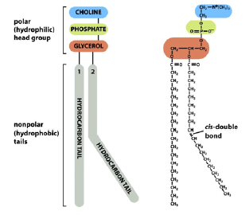

**Sphingolipids**: A fatty acid with instead an ester bond, there is an amide bond.

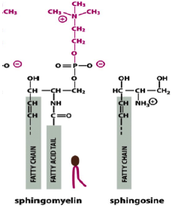

Sphingosine: generated from serine and a fatty acid CoA. Ceramide is generated through amide bond with free amino groups.

**Sterols**: Cholesterol in membranes (rather hydrophobic). Sterol in circulation. Ex.: corticosterone, testosterone, progesterone, cortisone.

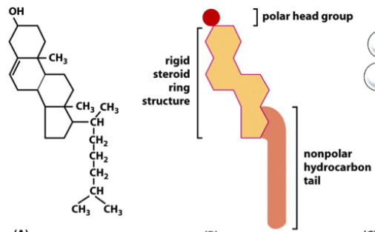

**Isoprenoids**: Examples are ubiquinone, retinol, carotene, prenyl lipids (can be added to proteins so that the proteins can stick to proteins), squalene (basis for sterol synthesis such as cholesterol). Sterols are made from isoprenoids.

**Membrane Proteins**

Monotopic transmembrane proteins only traverse the membrane once. Polytopic transmembrane proteins traverse the membrane more than once.

There are proteins that are covalently attached to lipids on the membrane (they are not TM proteins), we calll them lipidated proteins.

These two types summarize to integral proteins (can be either TM or lipidated protein).

A sister group are peripheral proteins (a protein that can attach to a integral protein or do NOT bind to a lipid like lipidated proteins).

The membrane is 6nm thick, 3nm of that are hydrophobic, so TM proteins they must be able to interact with the hydrophobic domain. Those interacting are exclusively composed of hydrophobic amino acids (this is called the alpha-helical segment).

**Hydropathy plot** lets us identify hydrophobic regions in a TM protein (alpha-helices):

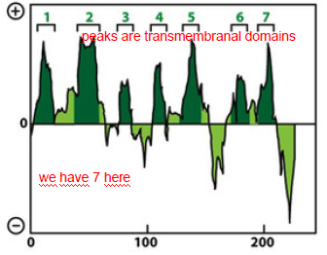

Exceptions are beta-barrels. They let hydrophlilic proteins go through the membrane. Beta barrels are found in the outer membrane of bacteria, mitochondria and chloroplasts. They are made of beta-sheets.

Why are they only found in mitochondria in our cells, but in bacteria everywhere? Endosymbiosis.

The functions of beta-barrels is to make pores. Mitochondria has lots of them, where actually all the proteins pass through (via machinery, that is absent in eukaryotic membranes).

**Lipidated proteins**

Protein originally made without a lipid and then post-translationally modified by a lipid (added to the protein).

Examples: Myristylation (amido bond between H3N terminus and COOH-terminus of myristyl (is C14)) is permament.  
Palmitoylation (fatty acid, looks just like myristyl, but it is C16; thioester bond) is reversible.  
Prenylation, prenyl group, is either geranyl geranyl or farnesyl (farnesyl is just slightly shorter than geranyl). They are added via a thioether bond between Cys and prenyl-OH. Placed at a CaaX box (C = cysteine, aa = two long alipathic amino acids, X = whatever C-terminus)

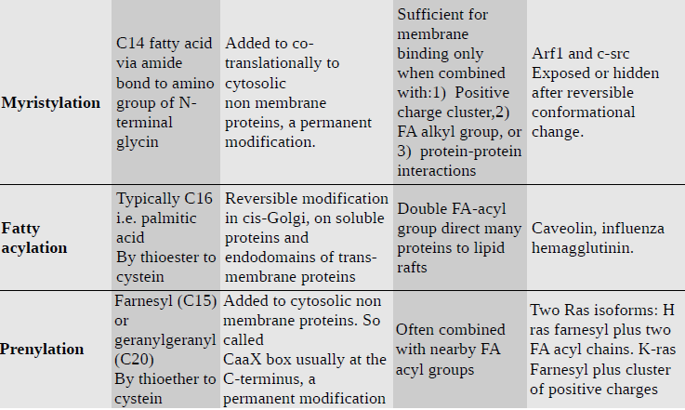

Lipidation takes place in the cytosolic side. There is one case that takes place in the extracellular side:  
**GPI anchoring** – proteins are just attached to it (on the extracellular side).

Importance of lipidation: support dynamic processes such that proteins can come on and off the membrane during signal transduction, molecular sorting, membrane bending, vesicle formation, membrane recognition etc. Regulation of dynamics is in time and space. Allow interaction of proteins with specific membranes only and with specific lipid microdomains such as lipid rafts.

**Peripheral proteins**

Clathrene coated pits occur in the endocytosis of proteins etc. Non-covalently attached to lipid head-groups or proteins in the membrane; Complex mixture of proteins on both sides of a membrane; Interactions are often transient and regulated; Cytosolic side of PM is particularly rich in peripheral proteins: an extensive, dynamic ‘cortex’ of actin, adaptor proteins, and other proteins (needed for membrane stability; local membrane specializations; connections with cytoskeleton; transmission of signals; trafficking of vesicles; cell shape and polarity determination; membrane curvature; endocytosis)

**Lipid diversity**

We have 4 main classes, but within the classes there are lots of different types that are combinatorial.

In fatty acids for instance, length varies from 14-22C, insaturations (0 – 6 poly unsaturated fatty acids (=: PUFA)). A FA can also change the polar head (positively or negatively charged).

Various glycerol heads can be:

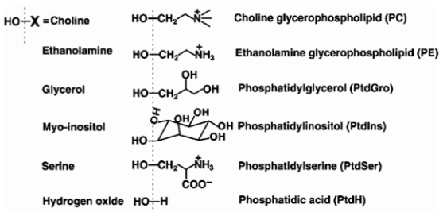

Different heads have different biophysical properties.

Difference between ethanolaime and choline: Ethanolamine can get rid of H+ in the acid for, while choline cannot.

It is estimated that there are around 100’000 different lipids (different heads and different tails lead to many combinations).

What determines if a lipid will for a bilayer or a micelles? Shape and size determine it.

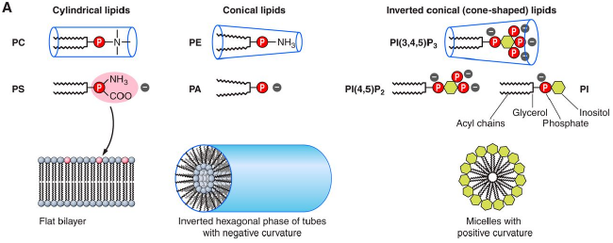

Detergents form micelles.

Oil does not have a polar head which is why they do not form a bilayer on water. They create droplets that can also occur in cells.

**Insaturations**

When there are kinks in the lipid, we get a more liquid membrane, because the interactions of the hydrophobic and hydropilic ends to not take place that well, which is why they don’t pack so nicely.

**Sterols**

Sterols make the membrane more rigid as they fill out the voids of the kined lipids for example.

**Gradients**: length and thickness of the membrane: ER < golgi < plasmamembrane.

Also, there is a asymmetric distribution in the monolayers, so the outer layers have a different composition than the intracellular membrane, which is logical due to the environment. As a rule, negatively charged lipids are more abundant (in the cytosol?).

Lipids that tend to have an affinity to each other tend to cluster together. It is due to van der Waals forces that is due to insaturation (that pack nicely together and that are chaotic).

Segregation in lipids: High temperature favors high entropy (=> chaos) and when you lower the temperature the degree of disorder will decrease, leading to the clustering phenomena.

**Lateral segregation**: In the ER, there is lots of PI, in golgi PI4P, in endosome PI3P and in plasmamembrane PI4,5P2 (abbreviated to PIP2).

How are lipids transported? It is not yet understood.  
Osh4 is a protein that binds a sterol in it. Osh4 can kick out the sterol and take up a PI4P. This transport occurs against the concentration gradient.

**Flippases and Scramblases**: They can transport a lipid from one leaflet to the other leaflet. Flippases use energy to act against the concentration gradient, while scramblases …

Both basically work like ion channels. Ion pumps example: P-type ATPases.

2.10.2017

Shape defines function and function defines shape.

In mitochondria, cristae are very important for mitochondrial function, so how do you get it? The crista has the cristae junction which is where all the F_1/F_0 ATPases are.

**Proteins that bend membranes**

**BAR-domain proteins**: Have a banana shape. When they attach to membranes (peripherally attached proteins), will cause a little increase in curvature in the membrane.

**Coat proteins**: cop1, cop2, clathrine are the best studied coat proteins.

**Wedge-like insertions of reticulon proteins**: Important for the tubular nature of the ER.

**Nucleus and its membrane**: So there are protein complexes on the nucleic site of the membrane and the cycplasmic site of membrane. There are receptors on the cytoplasmic site that go through the nuclear membrane “touching” the receptors attached to the nucleic site (that also go through the membrane). Cyplasmic stimuli can induce a response within the nucleus this way (?).

**Membrane fusion and fission**

There is fission, fusion and hemifusion (see fission and fusion in cell biology summary).

**On fission**

Liposomes won’t sponaneously fuse together due to the water (cytoplasm actually) between them:

Cell division: It requires energy, since polar side of membranes is hydrated, which is why the cell needs to overcome hydration energy. Also, the lipid bilayer is stable and it needs to be destabilized for cell divison.

Machineries for fission: 1) dynamins (and dynamin related proteins). Dynamin can spiral around an endocytic vesicle (dynamin is a GTPase), so it can like squeeze where it’s bound and “cut it apart”. Dyamins related proteins are important for mitochondrial fission (see cell biology summary).

2) ESCRT := endosomal sorting complex required for transport: important for hiv budding, used in last step of cytokineses and used for multi vesicular bodies. Some components of ESCRT are ATPases.

Dynamin does fission from the outside, ESCRT occurs from the inside (fission from inside). So, dynamin is cytoplasmic and ESCRT is non-cytoplasmic.

**On fusion**

Examples for fusion: fusion of gametes, mating in yeast, enveloped virus infection, mitochondrial fusion, vesicular trafficking and exocytosis. It also requires energy.

SNAREs: SNAP receptor, soluble NSF attachment protein, unstructured when not in a complex.  
There are SNAREs on the protein called v-SNAREs and on the outer membrane there are t-SNAREs, when they interact they fold and basically intertwine with the other SNARE. Neither one of them and ATPase or GTPase. The folding though is energetically more favorable that favors the folding (it only uses the folding energy). Reopening them again costs energy. NSF is the protein that provides the energy from reopening (NSF is a triple ATP, AAAATPase) at the expense of ATP hydrolysis.

There are further proteins helping fusion to happen: viral -> hemaglutinin and also dynamin related proteins (unknown why, because they are actually involved in fission, but apparently in fusion too.)

Cell fusion proteins (machinery unknown): mitofusin and OPA1 for inner and outer mitochondrial membrane fusion, atlastins for ER fusion, GTPases.

**Organelle Biogenesis**

**On mitochondria**: it is endosymbiotic, has two membranes, more han 4 compartments, the mitochondrial membrane is divided into (from cytoplasmic to matrix): OMM, IMS, IMM, matrix/cristae.

In yeast, mitochondria make FeS clusters. So, in a glucose rich medium, yeast actually uses energy (and does not produce energy) to make FeS clusters. Moreover, it also triggers apoptosis by rapturing the outer membrane of mitochondria, they are also involved in Ca2+ signalling and in innate antivirus defense.

Fission is catalyzed by the Dynamin related protein 1 (=: DRP1). It assembles around OMM as a contractile ring and also requires GTPases and is recruited by OMM-resident adaptor proteins to the site.

Fusion of IMM is catalyzed by Opa1 (and requires GTPases and dynamin related proteins).  
Fusion of OMM is catalyzed by Mitofusin (and requires GTPases and dynamin related proteins)

**Biogenesis of mitochondria**: There is a genome in mitochondria (mtDNA), also proteins, metabolites, lipids. Other facts: 20 kb, always maternally inherited (oocyte), has 12 proteins, encodes 20 tRNAs, 1000-2000 proteins are imported from the cell into the mitochondria, it also has rRNA.

How do lipids get into the mitochondria? The ER mitochondria encounter structure is a protein complex that is bound to the OMM and ER and the lipids like jump/are transported between them that way for transport (?). This protein complex seems to be very important, shape of mitochondria changes and the model organism (yeast in the experiment) becomes very sick.

How proteins are imported in the mitochondria: TOM for the outer membrane (TOM40 main subunit) and TIM for the inner membrane. Protein needs to be unfolded, have to go both through TOM and TIM (studied in vitro mostly). The unfolded protein has a MTS sequence (mitochondria target sequence) which will be imported into the mitochondria (the site with MTS goes in first).

TIM22 imports many IMM proteins. TIM23 imports many matrix proteins. SAM inserts beta barrel complexes from IMS to OMM. OXA1 inserts matrix-translated or matriximported proteins in the IMM. Import works in vitro, so no cytosolic factors are required.

How to check if protein really has been imported in the mitochondria: western blots and centrifugation. Or also, since the experiment is normally in a test tube, you can also add a protease that cannot access the mitochondria (MTS can be cleaved off, so that we can measure the amount of imported proteins and non imported proteins (since the protease will cleave the MTS off when it tries to enter and not when it is simply floating in the tube)).

**On chloroplast**

It is basically the same thing as in mitochondria: The outer membrane is called POM and the inner PIM. For the transport, we have TOC and TIC respectively, which are needed for protein import. Inside, there is the granae and thylakoid.

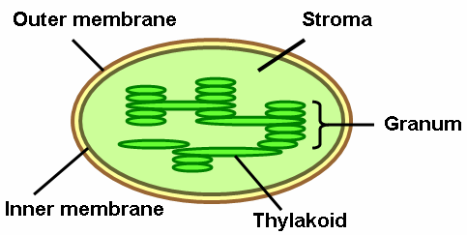

In a test tube, there are no chaperones and the protein is in a badly folded form (needs chaperones and a favourable folding environment) before it enters the chloroplast. In the chloroplast, there are chaperones to help it unfold.

There are 3 pathways for import: Sec, SRP, TAT pathway.

Sec pathway: Translocon homologous to bacterial SecYEG (eukaryotic Sec61).  
SRP pathway: Oxa1 related translocon, no RNA moiety, homologous to bacterial SRP.  
TAT pathway: twin-arginine translocon, relies on two adjacent arginines close to C-terminal.

**On peroxisomes**

Peroxisomes are not necessary for growth in yeast. How proteins are imported into peroxisomes is still unknown. Proteins imported are fully folded (no need for unfolding). It can even import gold particles. It imports proteins from ER or cytosol (cytosolic proteins have a C-terminal SKL sequence).

Functions: beta-oxidation, breakdown of fatty acids, innate viral defense, break down of ethanol, detoxification (generate H2O2 from O2), contains catalase (break down H2O2 to water and oxygen or use it for peroxidation).

Pink1 (PTEN-induced putative kinase 1) is constantly imported into mitochondria where it is degraded. When mitochondria lose membrane potential, protein import is inhibited. Therefore Pink1 accumulates on the mitochondrial surface. There it recruits Parkin, a ubiquitin ligase, which ubiquitylates many proteins on the OMM. This leads to the specific recruitment of the autophagy machinery and the subsequent degradation of mitochondria in autolysosomes.

**Trafficking**

9.10.2017

Overview of trafficking: sorting – budding – transport – recognition – fusion – recycling.

**ER to Golgi, Golgi to ER, Golgi to PM and early endosome, early endosome to late endosome to lysosome**

All of them are basically reversible except for cargo that is in the lysosome. What is in the lysosome stays in the lysosome. Also, PM to golgi does not really happen.

Methodologies: electron microscopy, light microscopy, pulse-chase approach, genetics (SEC screen, VPS screen), biochemistry approaches.

Observe secretory pathways with for example radiolabelled amino acids: radiohistochemistry: EM pictures allow us to see where radio label accumulates. Often in the ER.

Principle of pulse-chase: A **pulse-chase analysis** is a method for examining a cellular process occurring over time by successively exposing the cells to a labelled compound (pulse) and then to the same compound in an unlabelled form (chase).

Observe secretory pathways using genetics: **Sec screen (“Sheckman” in 80s)**: Yeast that cannot secrete proteins normally die. At 37 degrees, they cannot secrete, filling up secretion vesicles within them. Take them and centrifuge them on a sucrose gradient (changes the density of the medium, so the cells float and they can be separated using this neat trick). (those are cells on the verge of dying).  
Then, put them back at 25 degrees – the mutants become normal again. Sediment them by centrifugation. This way, we can find all the sec-mutants.

**Vesicle genesis**:

Clathrin for endocytosis and Golgi → PM trafficking. CopII for ER → Golgi (anterograde). CopI for Gogi → ER and intraGolgi (retrograde trafficking).

**Vacuolar protein sorting screen**: From ER, proteins go to golgi, then can go to PM or to endosome-lysosome:

**Invertases**: ER-golgi-PM, yeast cannot absorb sucrose, yeast can secrete invertases to make glucose out of sucrose and absorb it finally.

**Cyp carboxypeptidase**: ER-golgi-endosome-lysosome

**Note**: cyp-invertase fusion proteins go to the lysosome. Therefore, yeast cannot metabolize sucrose.

Observe secretory pathways using biochemistry: Principles:  
There are cargo receptors of a vesicle folded into the cell, so to say (increases cargo concentration locally).  
We have: Cop2 is anterograde (ER to golgi), Cop1 is retrograde (golgi to ER), clathrin at the PM for endocytosis and at the golgi that go towards PM and at the early endosome that go the PM.  
Retromer takes cargo from early endosome to golgi.

**Cargo sorting**:

How can we favour cargo disassociation, when the cargo should leave the cargo receptors? Take advantage of inherent pH value differences: ER>golgi>EE>LE>lysosome with ER quite neutral and lysosome quite acidic. So, when cargo enters a more acidic environment it will normally disassociate, but sometimes the opposite can also occur.

How can we recycle the cargo receptor so it goes back to the PM and the cargo goes to the lysosome?

Vesicles are not just spheres, they also have tubes sticking out of them. The receptor will normally go to the tube side (low volume, high surface) and cargo stays in the sphere part (high volume, lower surface) and the tubes will the sort of cleave off and become a (late) endosome with the receptors inside it.

**Retrieval**:

Sometimes, an ER resident protein can accidentally go into a vesicle and this vesicle fuses with the golgi. Such a protein has a signal sequence called KDEL (4 amino acid sequence, so these proteins that have to stay in the ER have evolved such a sequence). There is a KDEL receptor (pointing its receptive site inside the golgi) which can take proteins with KDEL as cargo, so it can be brought back.

**Conservation of membrane identity**:

How can an ER stay ER and not become a golgi for example?

**PIPs**: most important one for endocytosis: PIP4,5-P2 at the PM: Important for making the clathrin coat. There are synaptoganins in the coat, which is a phosphatase that destroys PI4,5P2 (:= PIP2) to PI.

So, PIP2 is in the PM and can always diffuse into the clathrin coat with the synaptojanin. Synaptojanin converts PIP2 to PI, which leads to disassembly of the clathrin coat

GTPase: Sor1 important for making Cop2. Arf important for making Cop1. Rab used in endocytosis amongst others.

GTPases will assemble at the membrane and travel to a GAP (GTPase activating protein – changes GTPase to GDPase). At the donor membrane (here the travelling membrane), there is a GEF, so that GDPase becomes GTPase (lecturer said: D form becomes converted to T form).

Early endosomes have Rab7 and late endosomes have Rab5.

**Exocytosis**: Process of making protein in the ER and finally bringing it to the PM:

**Journey of a protein in secretory pathway**: Protein is translocated by Sec61. Protein folds and it requires PTMs (post-translational modification) which are N-linked glycosylation, disulphide bonds.  
For folding, calnexin and calreculin are used – they are chaperons that bind glycan groups. If misfolded, then glucosyl transferase so that calnexin again affects the protein until proper binding occurred: This prevents a misfolded protein to leave the ER.

If you treat cells with an inhibitor with Cop2, then we get no golgi. We can wash off the inhibitor and here will be de novo creation of the golgi.

PM: constitutive exocytosis. Secretory granules: signal-mediated exocytosis (for example insulin signalling or more generally hormones and histamine and neurotransmitters). A very important signal is Ca2+ that activates synaptotagmin and this activates SNARE complex.

**Endocytosis**:

Functions: take up nutrients, downregulation of receptors (desensitation/adaption), eat up foreign objects (killing by phagocytosis), recycle proteins from PM.  
Examples for nutrients: LDLs, irons (transporter: transferrin).

HRP: not receptor mediated, linear increase of endocytosis with concentration of HRP.  
EGF: receptor mediated, logarithmic increases, can be saturated when no receptors are “free” anymore, effective at low concentrations already.

**Early endosome**: looks like a UFO, geometrical sorting, recycling of TM proteins. They can mature into a **late endosome**: is a multi-vesicular body. It will also fuse with a lysosome, which releases a lot of hydrolytic enzymes into the late endosome such as hydrolases and lipases that destroy the little vesicles within the late endosome.

How come the membrane of the lysosome and of the late endosome are not degraded too? Because they are very rich in glycolipids (glycocalyx). The glycolipids are in the lysosome and diffuse in the late endosome in order to protect the late endosome from destruction.

**Lysosomes**: degradative organelles (contains nucleases, proteases, lipases, phospholipases), acidic, terminal (no recycling of lysosomal content).

Lysosomes fuse with late endosomes/multivesicular bodies to generate an endolysosome. More than one lysosome can fuse with endolysosome. After digestion of the content, the endolysosome matures into a lysosomes, that can, again, fuse with a late endosome → the lysosome cycle.

Lysosomes also fuse with autophagosomes (double-membraned organelles product of autophagy) to form autolysosomes.

**Lysosomal acidification**: Mediated by the vacuolar H+-ATPase (v-type ATPase). Electrogenic: each proton pumped adds one + charge into compartment → build-up of + charges limits the acidification. Chloride channels (CLCs): Cl-/H+ exchangers, neutralize the charge of H+ → allow further drop of pH.

**PART 2**

Chromatin packaging is affected by: underlying sequence, histones (variants and modifications), chromatin remodelling enzymes, other DNA binding factors, architectural proteins.

DNA double helix is wound around a core of eight histone proteins: two H2A/H2B and H3/H4 dimers each. Nucleosomes is further packed into secondary structures (30 nm fibres). Euchromatin is accessible, heterochromatin is inaccessible.

**Histone modifications**: acetylation, methylation, ubiquitylation, phosphorylation (see GGB summary).

**DNA methylation**: In eukaryotes, DNA is methylated at the cysteine residues by DNA methyltransferases, which typically results in DNA repression. DNMT3A and 3B are de novo methyltransferases. DNMT1 is required for maintaining DNA methylation. DNA methylation typically results in gene repression.

**Telomere functions**: protect DNA from being recognized as DNA double strand breaks and from being degraded; act as tumour suppressors by limiting the proliferative effect of normal human cells; telomeres shorten after every cell division. When a certain critical shortness threshold is reached, it induces a cell death response (senescence, apoptosis). Telomeric human DNA is double-stranded TTAGGG repeats.

Telomerase enzyme is a reverse transcriptase that can add telomeric repeats to chromosomes ends de novo in each cell cycle and it is highly expressed in stem cells and in embryonic cells.

Acetylation makes the chromatin more open.

**RNA polymerase II**: Transcribes telomeric DNA into TERRA (ncRNA).

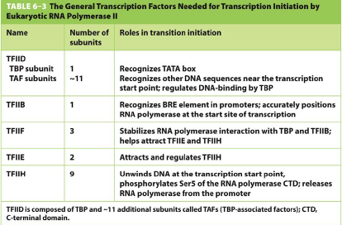

Non-conventional promoter elements: CpG islands: region with CpG content of over 70%. These regions are generally associated with house-keeping or ubiquitiously expressed genes. Several TSS are used.

**On mediator (complex)**: (might be very important since we answered an edu app question on it.)  
Mediator is a multi-subunit complex that provides a large interaction surface to contact DNA-bound transcription factors, general transcription factors, RNA Pol II and ncRNAs. It coordinates input from different TF and is important for gene loop formation. Mediator also regulates the transcriptional activity of RNA polymerase II. (**ask: how precisely do we need to know mediator and RNA polymerase 2.**)

Mediator does not bind to DNA and neither does mediator recognize DNA.

**On chromosome organization**: Important in development, differentiation and diseases.

Techniques:

Microscopy: Light microscopy, Electron microscopy, Live-cell imaging, superresolution microscopy: e.g. hetero- vs. euchromatin, subnuclear compartments, etc.

Chromosome conformation capture (3C) techniques: Use crosslinking to capture spatial proximities of the genome: e.g. new structural features of chromosomes, improved understanding of transcriptional regulation, etc.

ChIP-sequencing to analyze protein binding sites in the genome. Techniques to study chromatin organization in the nucleus: Hi-C.

Chromosomes have preferred positions, which may vary between cell types but are conserved between humans and primates. Gene-rich chromosomes are more central while gene-poor chromosomes are around nuclear periphery. Longer chromosomes and chromosomes with higher transcriptional activity occupy larger nuclear volumes, since they are open. Chromsome compartments are not conserved between cell types. They preferentially interact with each other (gene-rich/high activity with gene/rich-high activty or low-gene/low-activity with low-gene/low activity).

Topologically associated domains (TADs) are large genomic regions (~1 Mb on average) that display high levels of chromatin interactions within this region. TADs are often similar across different cell types, and partially conserved across species.

Hierarchy: chromosome territories, chromatin deparments (50kb resolution), TADs (10kb resolution), chromatin loops (5kb resolution).

Lamin-associated domains (LADs) are large genomic regions (0.1-10 Mb) that associate with the nuclear lamina. They contain few genes with low or no expression and are Strongly enriched for repressive histone marks. Constitutive LADs (cLADs) are maintained across a wide range of cell types and are highly conserved. Facultative LADs (fLADs) show variable association with the nuclear periphery (e.g. gene activation during differentiation).

6.11.2017

**Ribosome biogenesis**

(**FOR FURTHER REFERENCE – SEE PART 2 ZEMP_RIBOSOME-BIOGENESIS.PDF**)

Bacterial rRNA is synthesized as a polycistronic precursor, which is processed by several RNases to yield 16S, 23S and 5S rRNAs.

Modification or rRNAs: Methylations and pseudouridylations by snoRNPs amongst others. Also base methylations by specific methyltransferases.

**60S maturation**:

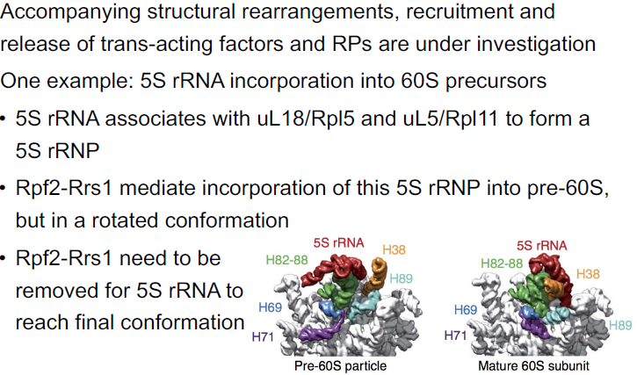

Export: Cytoplasmic steps in maturation:

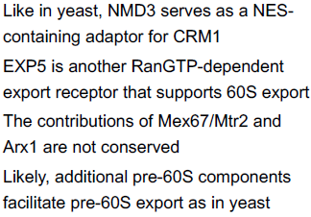 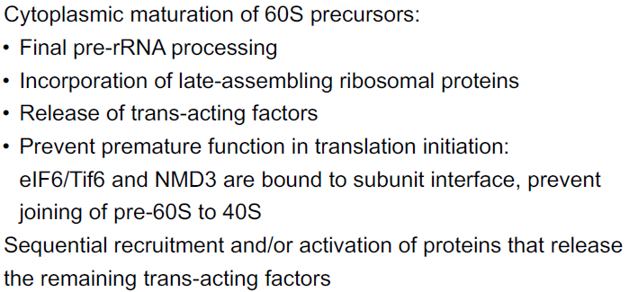

40S maturation:

Export: Cytoplasmic steps:

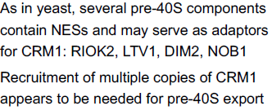 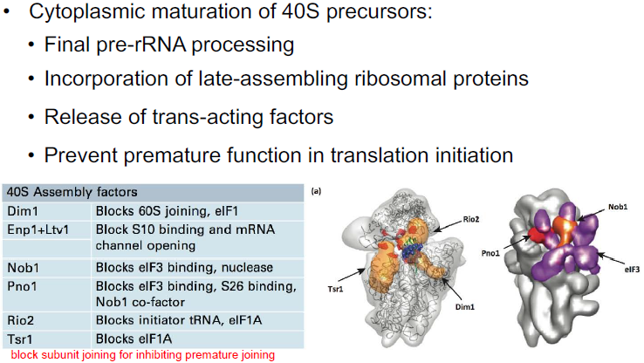

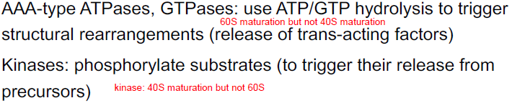

AAATPase is called Rea1 in human cells.

Also, know their differences and similarities.

**Differences and similarities between bacterial and eukaryotic ribosome biogenesis:**

Differences: in vitro assembly possibly/impossible, bacteria in one compartment vs. in nucleolus, nucleoplasm and cytoplasm, only few vs very many trans-acing factors.

In Eukaryotes, the pre-60S and pre-40S subunits are assembled in the nucleolus and exported into the nucleoplasm. Other factors add to it and the final subunits are exported via separate pores into the cytoplasm where they can combine together for translation.

Similarities: pre-rRNA produced as a polycistronic precursor, rRNA is modified, role of ribosomal proteins in stabilizing secondary structures, mediating tertiary structures, etc., trans-acting factors that have similar activities (e.g. endo-/exonucleases, RNA helicases, kinases, AAA-ATPases, GTPases, etc ).

Rough order of the following steps in rRNA maturation: transcription, modification, processing/secondary structure formation (locally: processing first, globally: can differ), binding to ribosomal proteins.

RNA Pol I transcription initiation depends on:

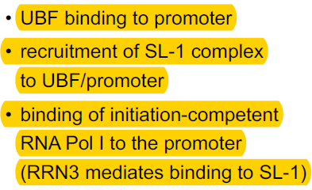

The pre-rRNA precursor is processed to the mature 18S, 5.8S and 25S rRNAs (28S rRNA in mammalian cells).

Recognition of improper pre-rRNA:

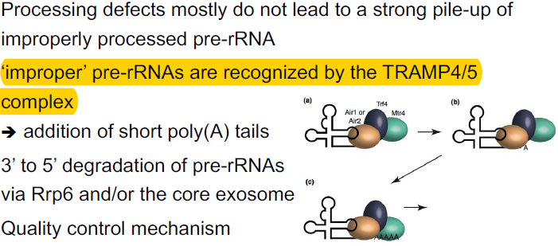

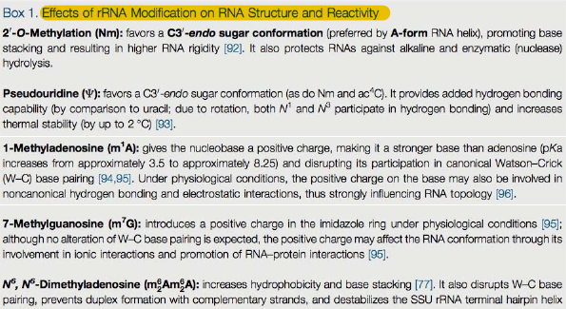

04.12.17

**PART 4 – The ubqiuitin-proteasome system**

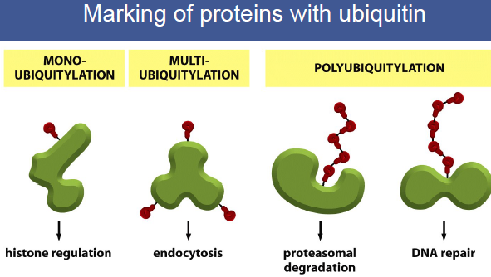

Ubiquitination often occurs at lysine side chains, but sometimes also at non-lysine side chains.

There are monoUb, modified monoUb, homotypic, modified homotypic, mixed and modified mixed, branched and modified branched ubiquitinations. They can also be acetylated and phosphorylated.

Three important enzymes in ubiquitination: E1/2/3. There are two types of E3 ligases: HECT domain and RING finger ligases.

**Marking of proteins with ubiquitin**

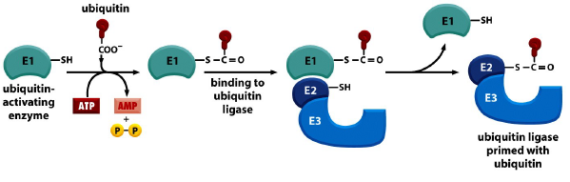

**Substrate recognition**

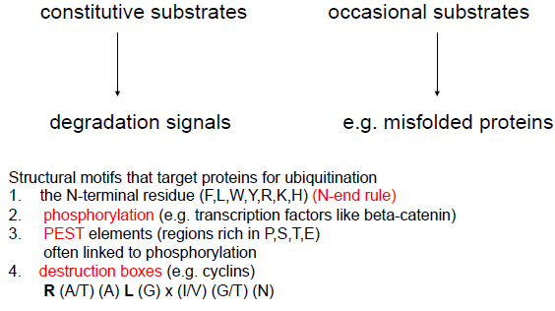

**Deubiquitylating enzymes (DUBs)**

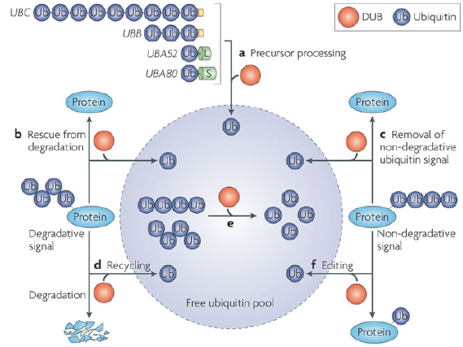

**The degrading machinery, the proteasome**

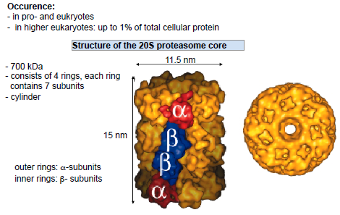

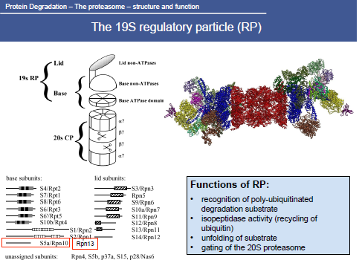

**Autophagy**

Cellular homeostasis: recycling of cellular building blocks.  
Organelle homeostasis: degradation of superflous and damaged organelles.  
Adaptation to chaning environmental conditions.  
Protection and defense: removal of protein aggregates and intracellular viruses and bacteria.  
Biosynthetic functions such as the transport of vacuolar enzymes.

Autophagy has important functions in the development of an organism (e.g. autophagy and apoptosis of neurons during early development). Other: differentiation, development, cellular homeostasis, adaptive response to starvation, cellular defense, quality control.

Complexes involved: Atg1 (protein kinase in vacuole), Atg9 (transmembrane protein of vacuole), Vps34 complex (lipid protein kinase), Atg2/18 (PI3P binding), Ubl protein system (Atg8 lipidation).

**Identification of ATG proteins**: Screen yeast for absence of autophagy bodies.

Types of autophagy: mitophagy (neurodegenerative diseases), lipophagy, virophagy (infectious diseases), ERphagy (only small parts, because too big parts are problematic for the autophagosome), aggrephagy (neurodegenerative diseases), nucleophagy, pexophagy, bacteriophagy (infectious diseases).

Bulk/macroautophagy is nutrient regulated. In selective autophagy, the cargo signals its own degradation.

**Bacteriophagy**: Ubiquitination of bacteria (bacteria tries to get rid of it as a response), binding of p62 and optineurin, recruitment of autophagy machinery, ATG8 recruitmen on p62 and optineurin (and NDP52), TBK1 kinase recruitment (promotes autophagosome formation by co-recruiting WIPI2 + phosphorylation of optineurin to enhance ATG8 binding affinity), membrane formation.

Reduction of mitochondria: reduced metabolic demand, cone cells during hibernation, quality control and prevention of toxic mitochondrial products.

**Mitophagy**: upon mitochondrial damage Pink1 accumulates in the outer mitochondrial membrane, Pink1 phosphorylates ubiquitin, phospho-ubiquitin recruits the E3 ubiquitin ligase Parkin, Pink1 further activates Parkin by phosphorylating its Ubl domain, high Parkin ubiquitination activity plus Pink1 mediated phosphorylation of transferred ubiquitins, recruits cargo adaptors with ubiquitin binding domains (e.g. TAX1BP1, p62, NDP52 and Optineurin), TBK1 recruitment, which lead to autophagosome formation and selective elimination of damaged mitochondria.

18.12.2017

**Protein aggregation diseases and physiological protein aggregation**

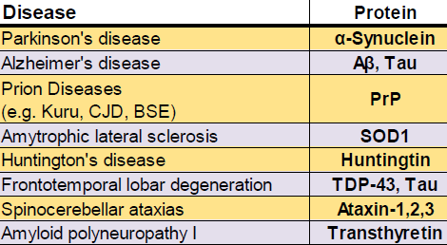

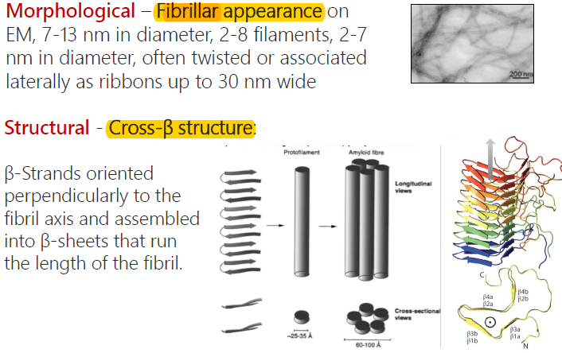

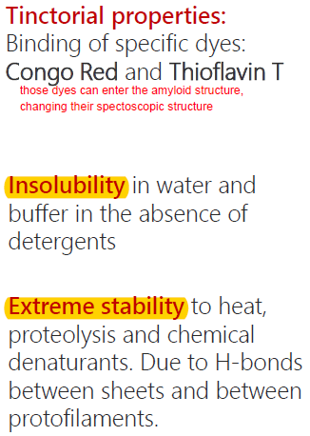

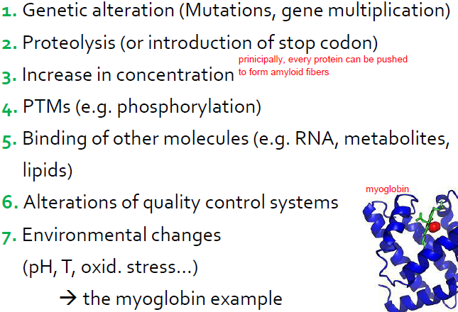

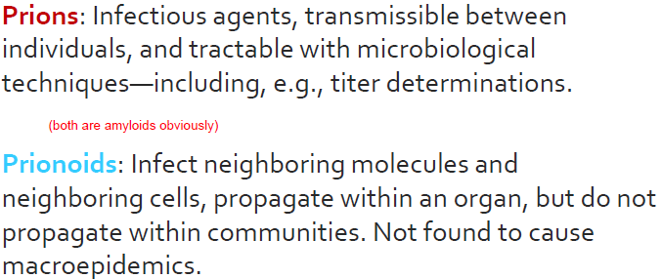

The aggregation propensity of a protein is determined by different factors. Extrinsic factors: interactions with cellular components, physico-chemical properties of the environment. Intrinsic factors: charge, hydrophobicity, secondary structures preferences, polar residues. About 40% of any eukaryotic proteome is disordered. It is another regulatory mechanism of protein activity. Protein aggregates can also perform certain functions in the cell. Disordered regions also exert additional functions in cells.